Nama : Osvaldo Xavier Maximillian

NIM : 2602164111

**Penjelasan Jetflix**

Jetflix adalah platform streaming yang merupakan clone dari Netflix Disini pengguna bisa menyaksikan banyak film dan tv series. Saat mengunjungi jetflix pengguna akan langsung berada di homepage, pengguna akan diarahkan untuk sign up sebelum menggunakan jetflix. Saat berada di sign up page pengguna diharuskan mengisi nama,password,konfirmasi password,tanggal lahir,gender, dan checkbox persetujuan terms and condition. Pengguna yang sudah melakukan sign up akan langsung diarahkan menuju Movies Page yang berisi Navbar yang membantu pengguna terhubung dengan Home page dan news & popular page. Pengguna juga ditampilkan jumbotron dengan best film sebagai latar, penonton bisa melihat judul,cast, dan synopsis di jumbotron. Penonton diberi 2 tombol di jumbotron yaitu play button dan information button. Information Button akan langsung mengarahkan pengguna menuju Detail Page yang berisi informasi tentang film yang ditampilkan di jumbotron, disana pengguna bisa melihat poster,judul,genre,cast,synopsis dan deretan episode. Setiap episode dilengkapi dengan judul,durasi,synopsis,play button, dan foto screenshot episode tersebut. Pengguna bisa Kembali ke movies page dengan menekan tombol back di kiri atas. News&Popular Page menampilkan 5 film terbaik di jetflix. Setiap film menampilkan screenshot dari film masing masing,judul,genre,synopsis,play button, dan download button

**Movies Page**

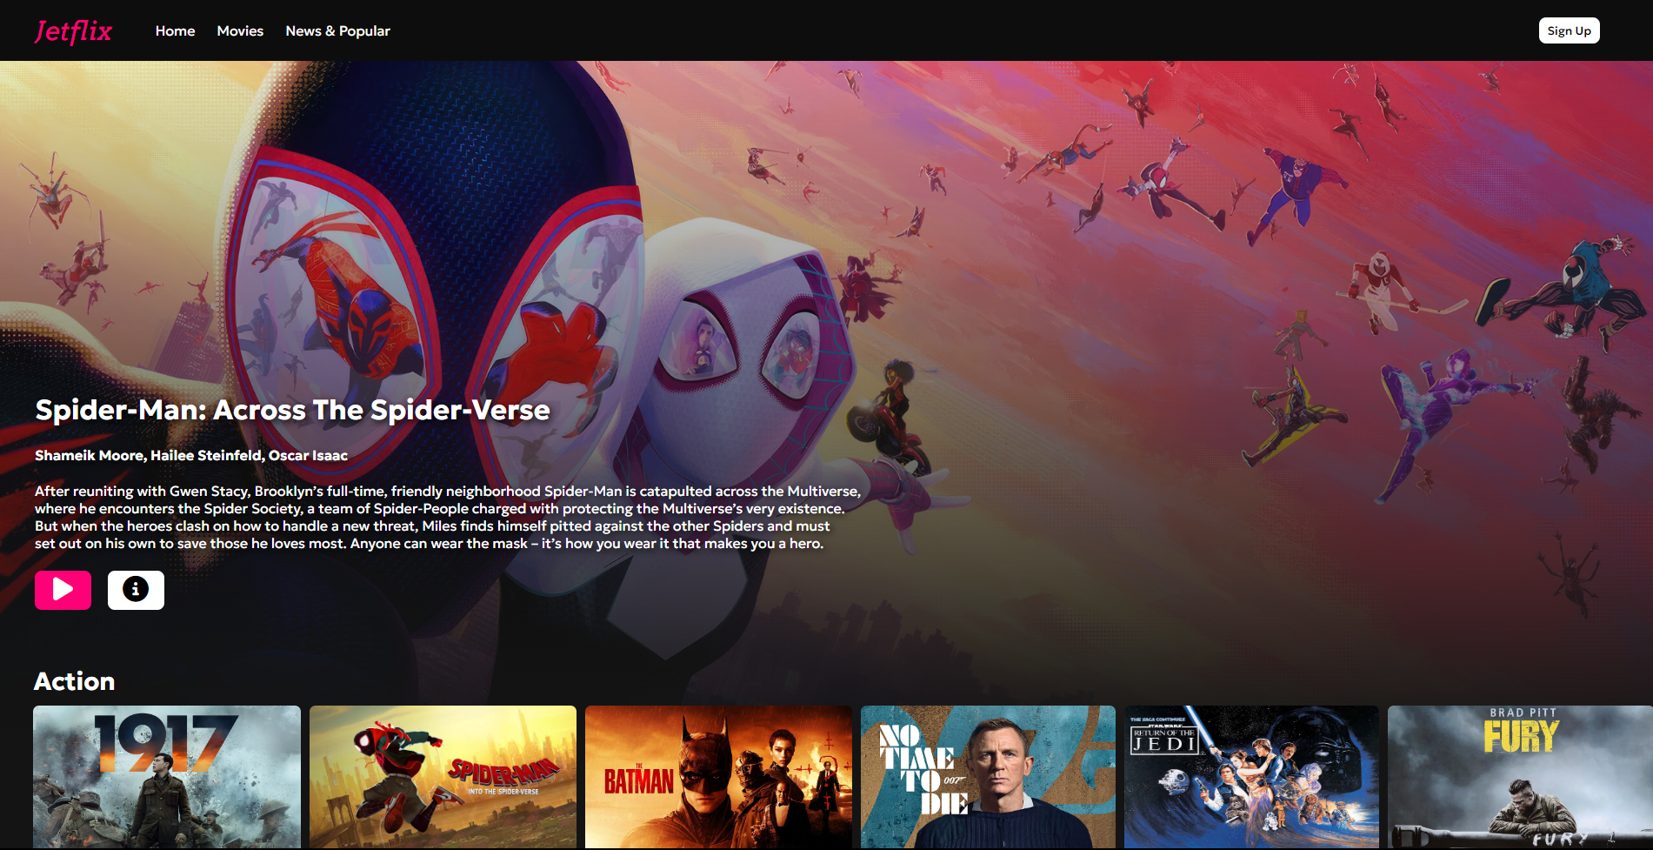

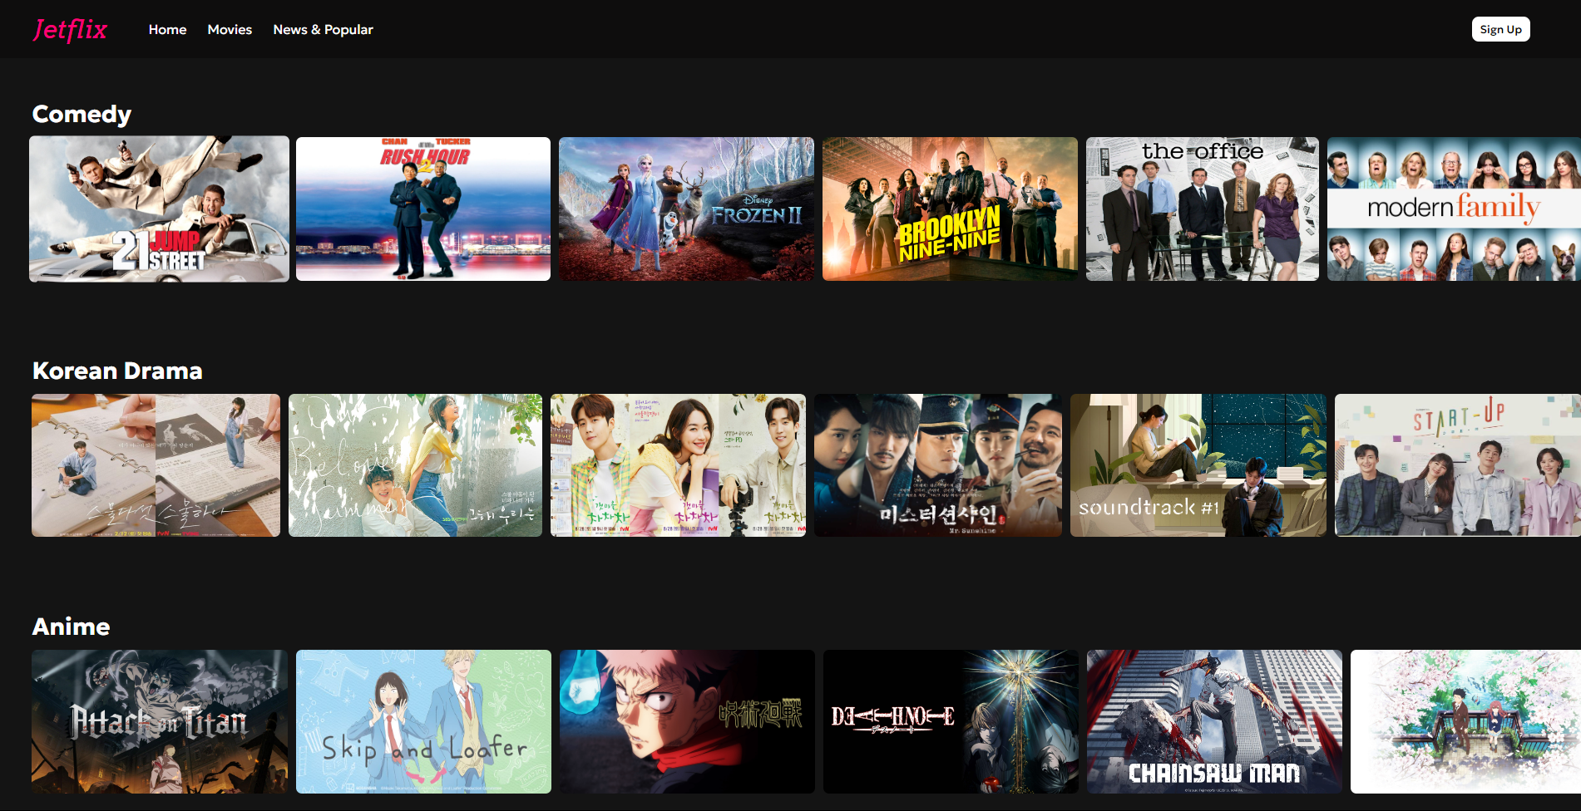

Jumbotron : <https://www.uhdpaper.com/search?q=%7b7261kjpg%7d&i=0>

Action :

* <https://images.squarespace-cdn.com/content/v1/5fbc4a62c2150e62cfcb09aa/33e62911-2708-4875-9c71-9926f571e1c1/The%2BBatman.jpg?format=1000w>
* <https://geekshavegame.com/wp-content/uploads/2021/10/HD-wallpaper-007-no-time-to-die-2020-daniel-craig-films-poster.jpg>
* <https://wall.alphacoders.com/big.php?i=1109850>
* <https://img1.hotstarext.com/image/upload/f_auto,t_hcdl/sources/r1/cms/prod/523/1280523-h-3a226c331963>
* <https://twitter.com/sw_holocron/status/1003002449630846976?s=20>
* <https://img2.hulu.com/user/v3/artwork/30f7e368-a33d-4cc3-a0c1-9b060d74f819?base_image_bucket_name=image_manager&base_image=5bd2529a-6dc0-4535-81ea-bf405ce63c28&region=US&format=jpeg&size=952x536>

Comedy :

* <https://fanart.tv/movie/64688/21-jump-street/?section=all>
* [https://miro.medium.com/v2/resize:fit:2000/0*OZyODGbtsiIbWo4o.jpg](https://miro.medium.com/v2/resize:fit:2000/0*OZyODGbtsiIbWo4o.jpg)
* <https://img1.hotstarext.com/image/upload/f_auto,t_web_hs_2_5x/sources/r1/cms/prod/1078/651078-h>
* <https://cdn2-ttvbo.prod.facade.telstra.com.au/api/v2/img/5f96248ee4b0816b58971c91-1629066792096?location=series-cover-art>
* <https://flxt.tmsimg.com/assets/p7893513_b_h9_ab.jpg>
* <https://img1.hotstarext.com/image/upload/f_auto,t_web_m_1x/sources/r1/cms/prod/7538/617538-h>

Korean Drama :

* <https://www.pxfuel.com/en/desktop-wallpaper-odjfa>
* <https://wallpapercave.com/our-beloved-summer-wallpapers>
* <https://1739752386.rsc.cdn77.org/data/images/full/246077/hometown-cha-cha-cha.jpg>
* <https://www.layar.id/wp-content/uploads/2018/08/mr-sunshine.jpg>
* <https://imgsrv2.voi.id/MwUI3YlTNAQri0mdR5eSVWKJlRBWVItnBu4j58QwOMw/auto/1200/675/sm/1/bG9jYWw6Ly8vcHVibGlzaGVycy8xNDQ1ODgvMjAyMjAzMTIxNjQyLW1haW4uY3JvcHBlZF8xNjQ3MDc4MTc3LmpwZw.jpg>
* <https://kinipaham.com/wp-content/uploads/2020/12/Poster-Drama-Startup.jpg>

anime :

* <https://encrypted-tbn0.gstatic.com/images?q=tbn:ANd9GcQ6eidCuaDxK0weKIDXW_VV0aYWgWacTMjzSxMWL2akbPvT45ECBqBQ1v05267bx58mAqQ&usqp=CAU>
* <https://butwhytho.net/wp-content/uploads/2023/04/Skip-and-Loafer-%E2%80%94-But-Why-Tho.jpg>
* <https://img1.hotstarext.com/image/upload/f_auto,t_hcdl/sources/r1/cms/prod/6922/1176922-h-37162967be27>
* <https://imageservice.disco.peacocktv.com/uuid/35a2730a-8fae-3174-add2-f95b8bddf8ad/TITLE_ART_16_9?language=eng&territory=US&proposition=NBCUOTT&version=dc42162c-0555-3007-961c-f487507cb2f0>
* <https://pbs.twimg.com/media/FZCC3AUXwAE84GG.jpg>
* <https://images3.alphacoders.com/691/thumb-1920-691201.png>

**Detail Page**

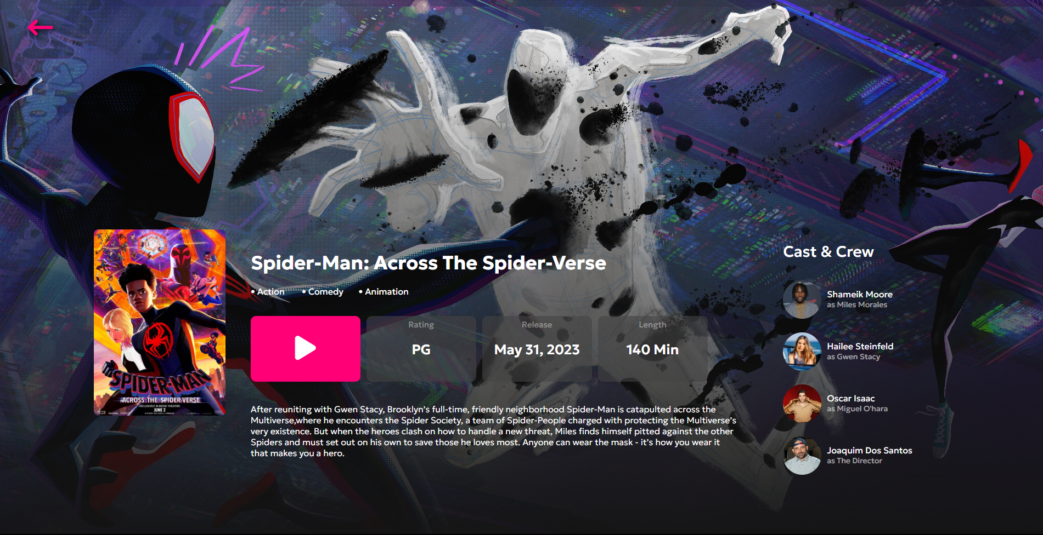

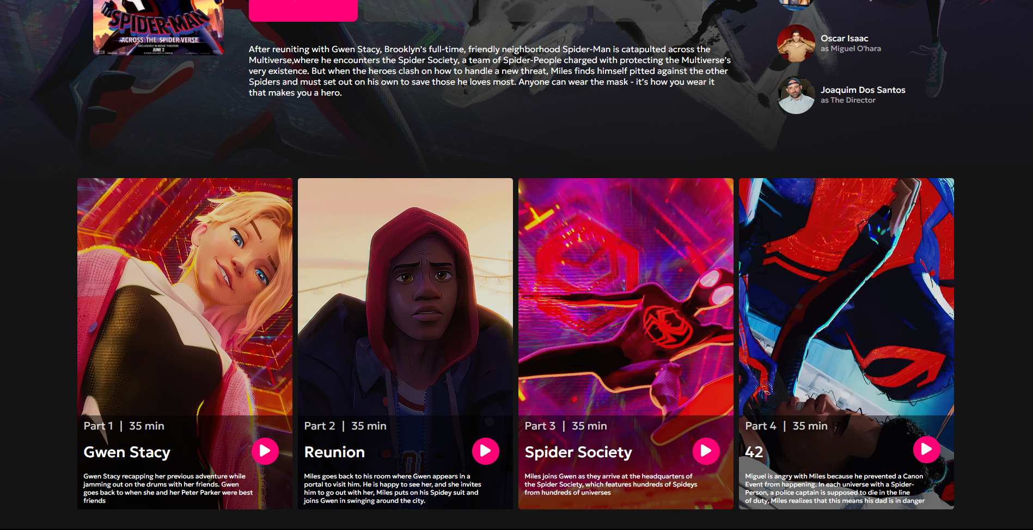

Banner : <https://hips.hearstapps.com/hmg-prod/images/miles-morales-gwen-stacy-the-spot-spider-man-across-the-spider-verse-6475c68d3635b.jpg>  
vertical poster : <https://m.media-amazon.com/images/M/MV5BNzQ1ODUzYjktMzRiMS00ODNiLWI4NzQtOTRiN2VlNTNmODFjXkEyXkFqcGdeQXVyMTkxNjUyNQ@@._V1_FMjpg_UX1000_.jpg>

Cast :

* <https://i2-prod.mirror.co.uk/incoming/article13775372.ece/ALTERNATES/s1200c/0_US-ENTERTAINMENT-AUGMENTED-REALITY.jpg>
* <https://lastfm.freetls.fastly.net/i/u/770x0/587669205b8eb1f52c1636e04cc82938.jpg#587669205b8eb1f52c1636e04cc82938>
* <https://media.gq.com/photos/5a8c1e305c39ed0b371ac45b/1:1/w_3000,h_3000,c_limit/oscar-isaac-gq-style-18.jpg>
* <https://www.sonypicturesanimation.com/sites/default/files/styles/max_375_x_390/public/2023-01/Joaquim%20Dos%20Santos.jpg?itok=c-ZzLcG->

Episode :

* <https://www.uhdpaper.com/search?q=%7b8990hjpg%7d&i=0>
* <https://www.uhdpaper.com/search?q=%7b8820hjpg%7d&i=0>
* <https://www.uhdpaper.com/search?q=%7b6791ejpg%7d&i=0>
* <https://www.uhdpaper.com/search?q=%7b9060hjpg%7d&i=0>

**News & Popular Page**

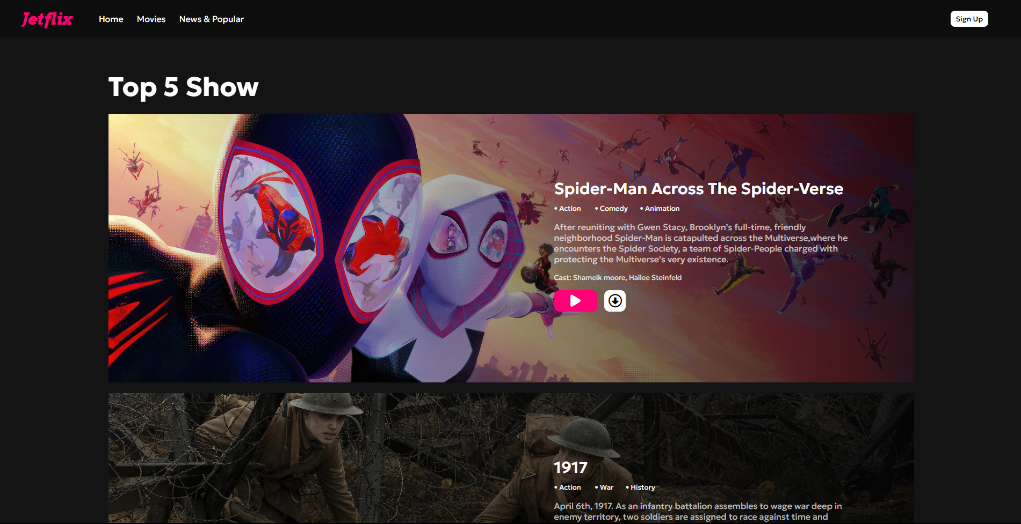





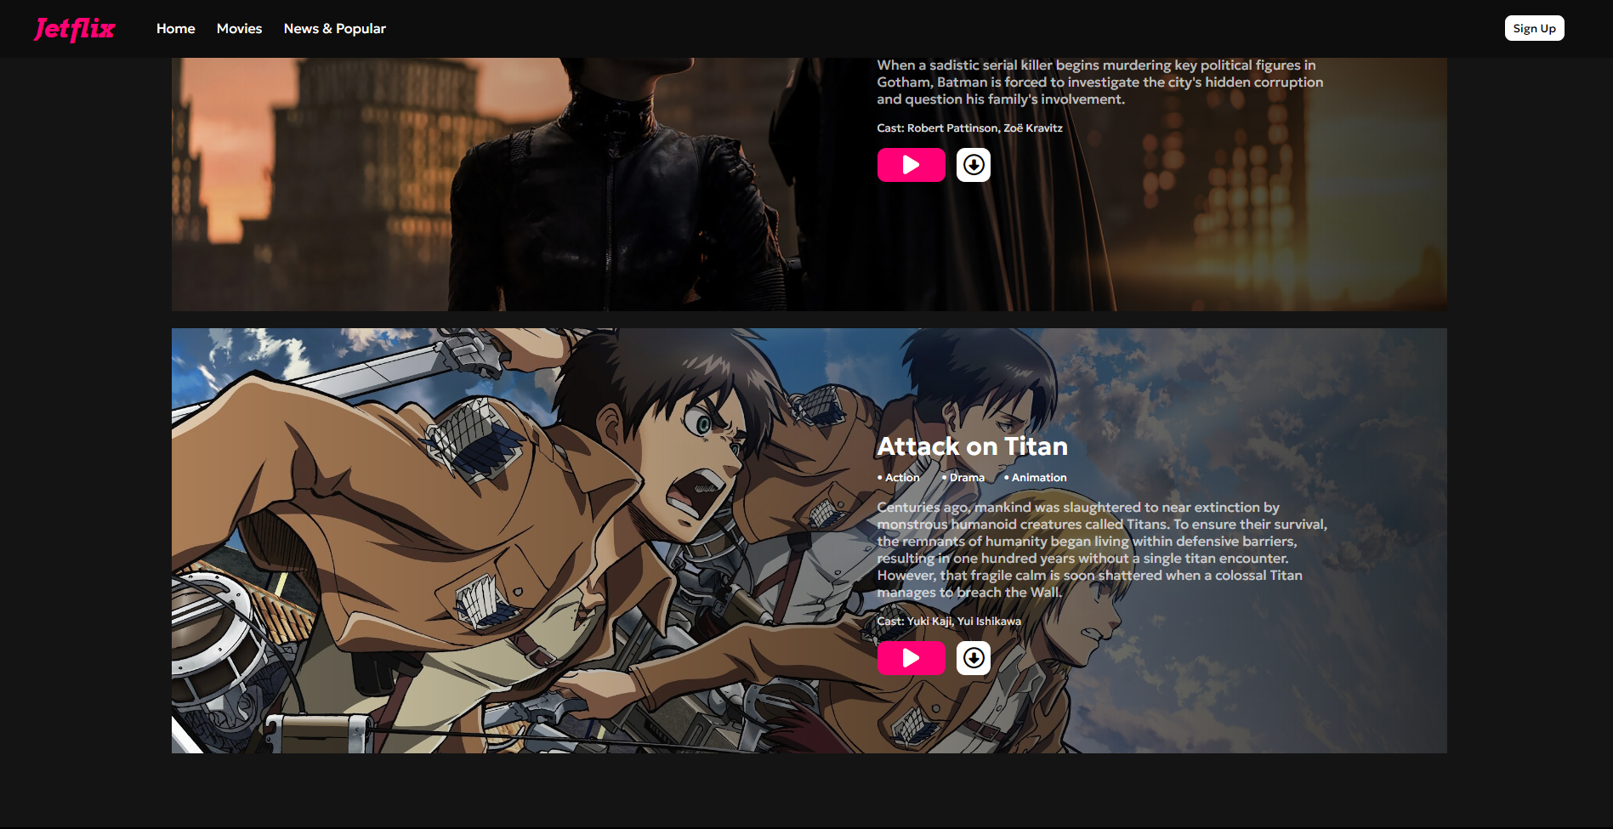

Top 5 show :

* <https://www.uhdpaper.com/search?q=%7b7261kjpg%7d&i=0>
* <https://wall.alphacoders.com/big.php?i=1063700>
* <https://www.pxfuel.com/en/desktop-wallpaper-odjan>
* <https://www.uhdpaper.com/search?q=%7b8431fjpg%7d&i=0>
* <https://3.bp.blogspot.com/-_jMRB5hwgH4/XSRJPVTi1cI/AAAAAAAAAjQ/9ZEopbjGid0Qg0b0A3OdRkMGNgaHBy7cQCKgBGAs/w2560-h1440-c/eren-mikasa-armin-levi-attack-on-titan-uhdpaper.com-8K-54.jpg>

**Home**

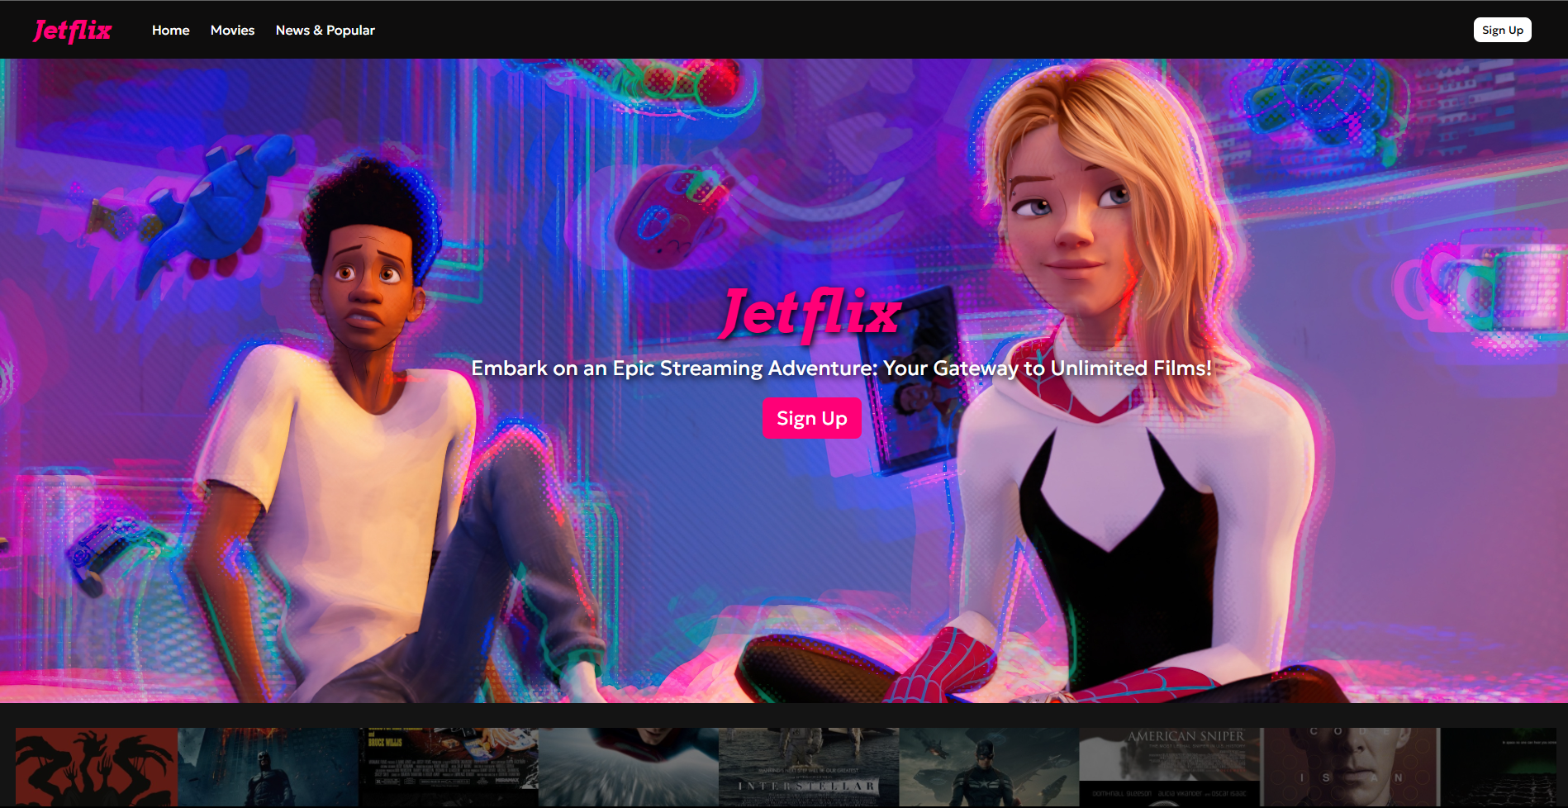

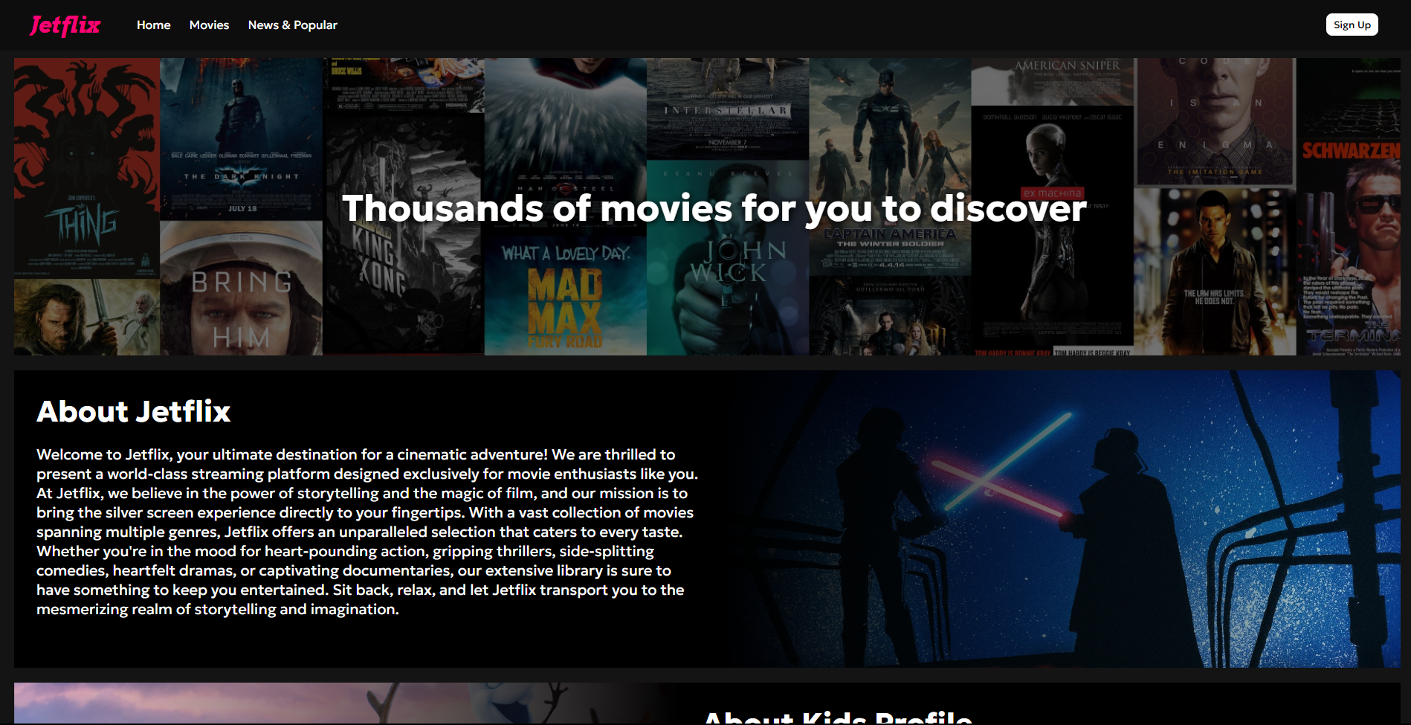

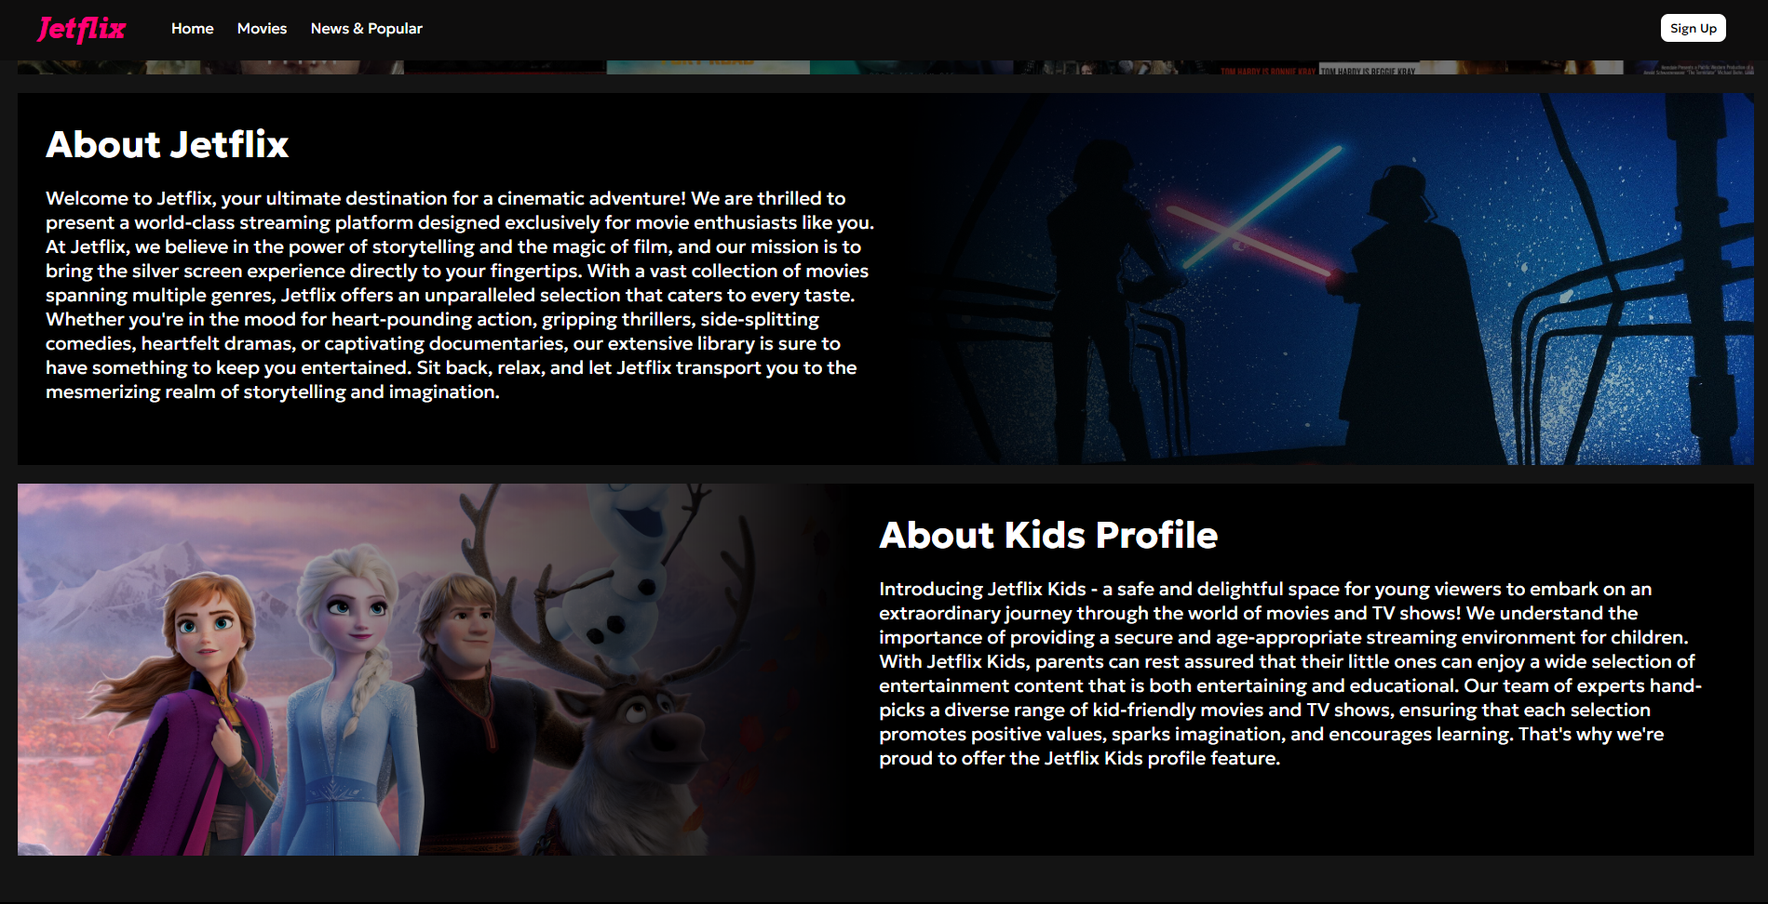

Banner : <https://www.uhdpaper.com/2022/09/spider-man-across-4k-8840h.html>

<https://e0.pxfuel.com/wallpapers/442/396/desktop-wallpaper-film-posters-collage-movies-resolution.jpg>

<https://www.uhdpaper.com/2019/10/frozen-2-movie-poster-8k-31274.html>

<https://www.wallpaperflare.com/star-wars-movie-scene-luke-skywalker-darth-vader-anakin-skywalker-wallpaper-hujsj>

**Sign Up**



<https://www.peakpx.com/en/hd-wallpaper-desktop-awdld>

**Responsive 768px**

**Home Page**

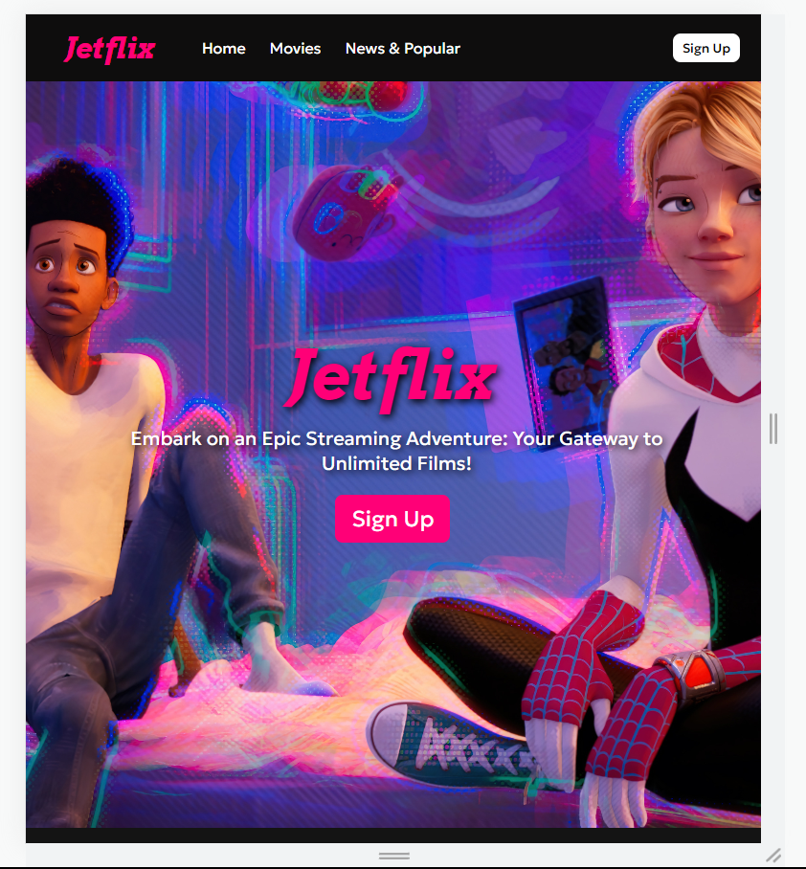



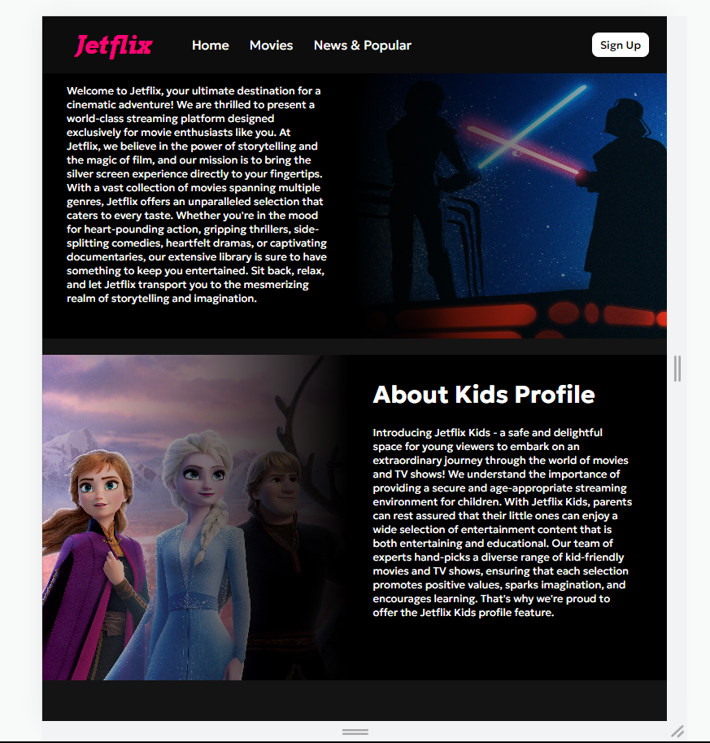

**Movies Page**

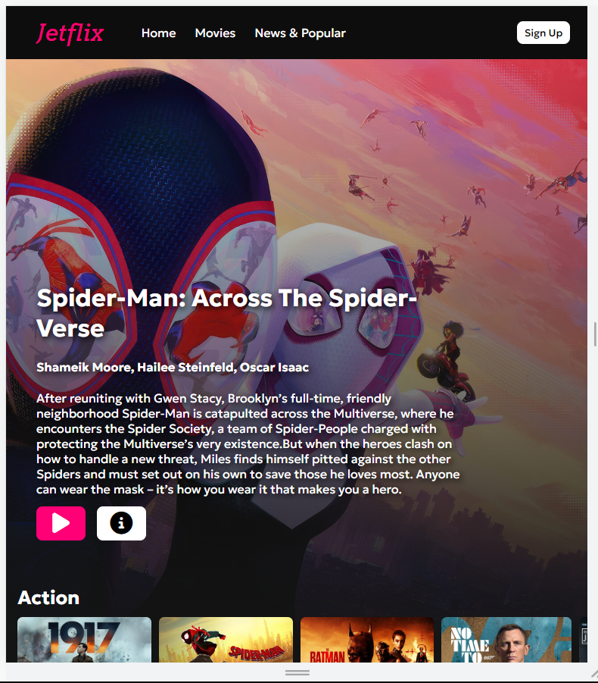

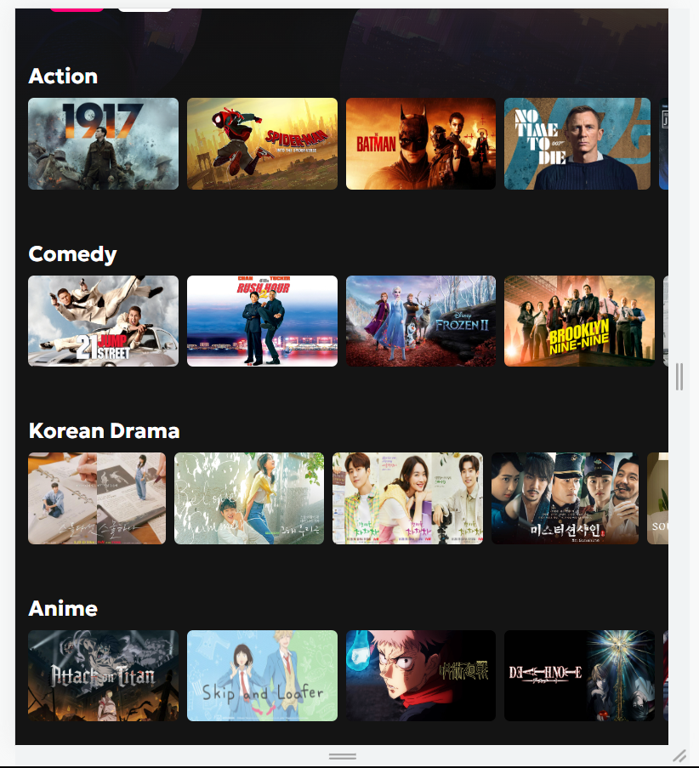

**News & Popular Page**

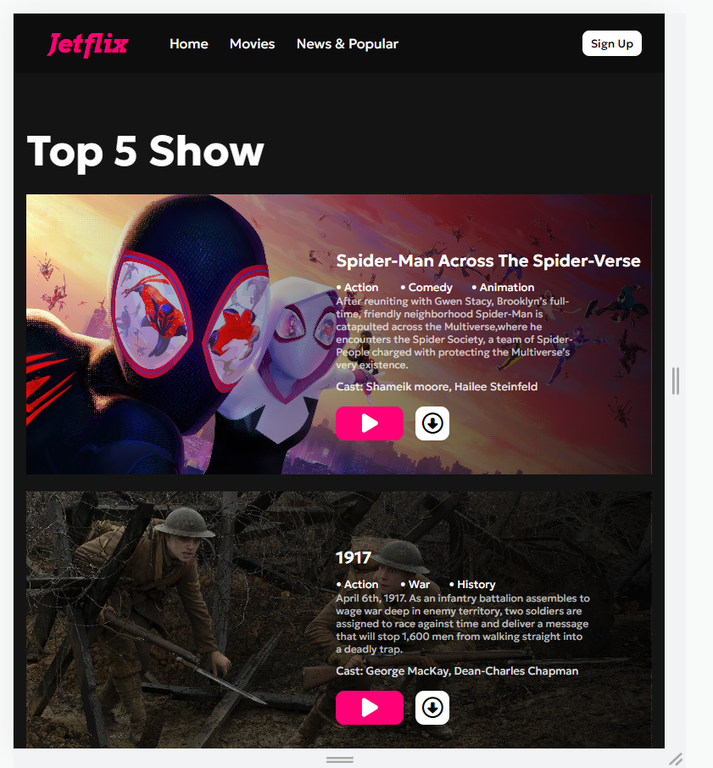

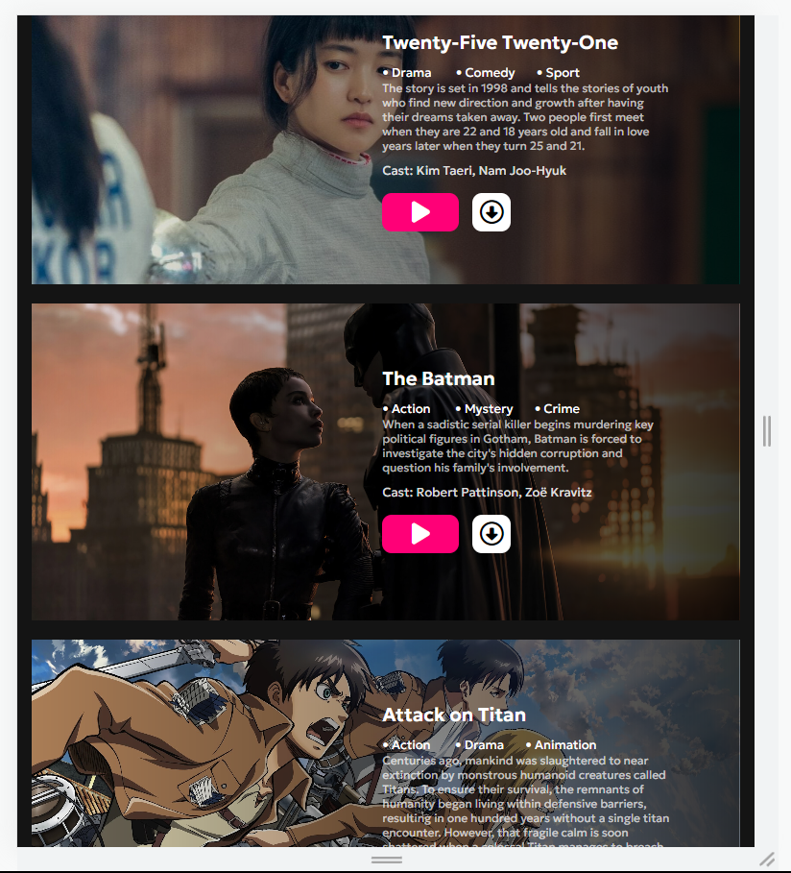

**Sign Up Page**

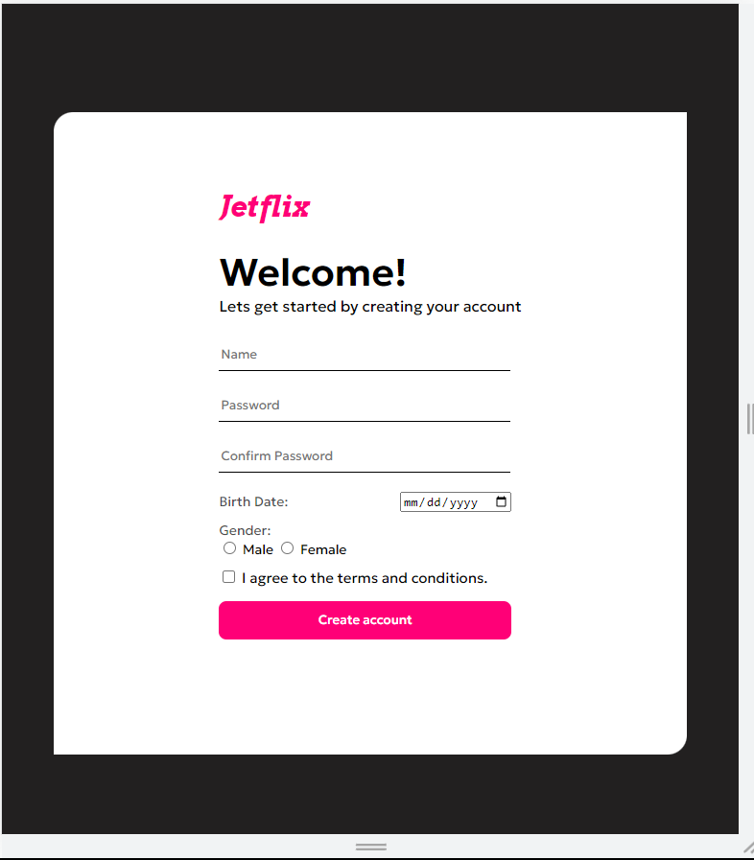

**Detail Page**

